MATERIALS:

1. L298N MOTOR DRIVER MODULE- 1pcs

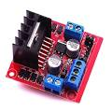

2. YELLOW DIY 12V DC MOTORS: 4pcs

3. MPU5060 SENSOR-1Pcs
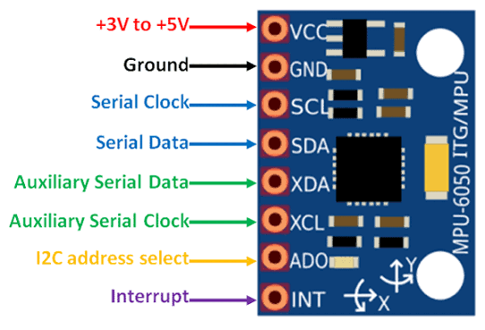

4. Dual battery holder: 1pcs

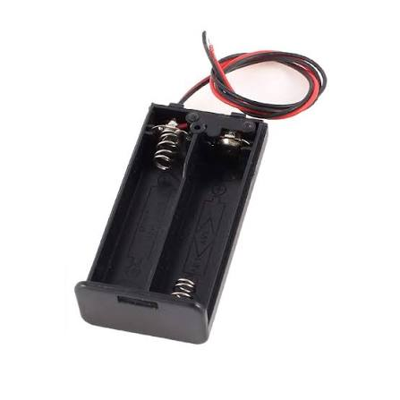

5. 3.7V battery -2pcs

6. Plastic robot car small wheels: 4pcs

7. 3D printed car:

